Motorsport Powertrains(A25) Assignment

Name- Aniket Tupe

Reg No. – 473155

Email – [aniket.tupe.155@cranfield.ac.uk](mailto:aniket.tupe.155@cranfield.ac.uk)

**Task 1**

Objectives –

* Optimise the intake geometry to improve overall engine performance metrics.
* Optimise camshaft phasing for enhanced performance across the same parameters.
* Overlay the optimised results on the same graphs as the baseline results for visual comparison.

We’ll first compare the stock engine model with a optimized engine model across various parameters then discuss cause and effect relation of each parameter change to performance change

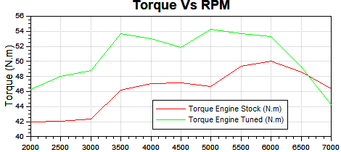

The torque is great in the midrange with increase of 20%but drops and is worse than stock at 6500RPm+

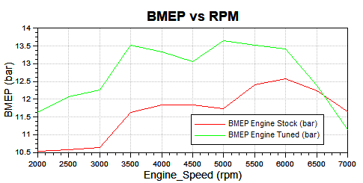

Same relation as torque with about 20% increase

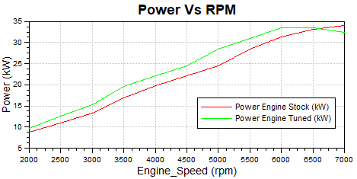

The power has about 20% increase except above 6500+ RPM

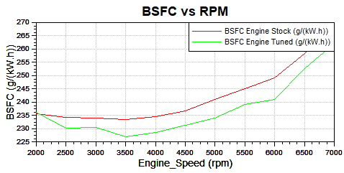

The BSFC shows a decent deduction of 2% in the tuned engine which can lead to higher mileage of the engine

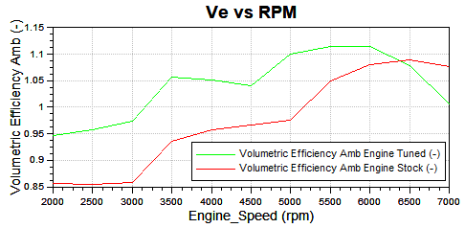

The VE shows about 10% increase indicating much better mass airflow in the tuned engine

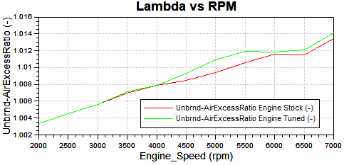

The Lambda is very similar to the stock engine not showing any significant inprovement

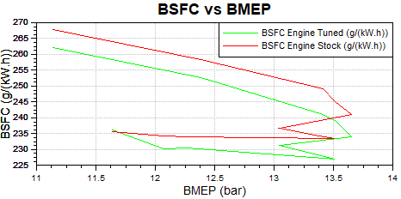

As is visible from all the graphs above the tuned engine performs better in most of the performance metrics than the stock engine except above 6500RPM, this drop in performance can be attributed to choking of the engine caused by using a lower diameter pipe this is trade off between higher middle end torque vs having worse performance at higher RPM , the only major concern with this kind of performance is drop in peak power of the tuned engine of about approximately 10% . Therefore this engine has to be tuned further for high RPM performance. But this being a smaller engine it is expected this engine requires higher torque requirements and thus higher acceleration at the mid RPM range.

To tune the engine the following parameters were changed:

* Length of the Intake
* Diameter of the Intake
* Start of Combustion Timing
* Intake shift
* Exhaust shift

**For Length Selection**

The tuning of intake as discussed is decided by the wave dynamics, where resonance occurs at between pressure waves and the intake length is just perfect(in most cases) that the air intake increases basically the air is being pushed in more due to the constructive interference of two pressure waves. But for a length of intake there is also possibility of causing destructive interference at a specific rpm and that effect has to be minimized. The effective intake length can be calculated by the formula

c = (yRT)^1/2 => y – gas coefficient(1.4), R – Gas Constant(287), T – Temps in Kelvin(293),

the Resonant Length L = c/(4*RPM/60)*n

here L = intake length, c = speed of air wave which has to be below speed of sound to avoid going supersonic and avoid a sonic boom(340 ms-1), RPM = desired engine RPM, n = nth harmonic of the wave ,

So, using above calculations and targeting high torque at about 5000RPM, the intake length is taken approximately to be 160mm considering packaging requirements. Using nth harmonic and depending upon space available the length can be varied for example length at 1st and 2nd harmonics will be much higher as compared to 4th and 5th harmonics but wave strength is inversely proportional to it.

**For Diameter selection** trial and error method was relied on to find the maximum peak torque and after multiple iterations 33mm was selected as the intake diameter , it was observed that at lower diameter a slightly higher torque was achievable but the high RPM torque was reduced by a lot due to choking, similarly using a higher a diameter pipe was resulting in slightly higher torque at higher rpm range but the max peak torque was much worse, so after multiple iterations 33mm was decided as the value for intake diameter.

**For Start of Combustion Timing** there’s a general understanding that as the rpm increases the spark has to be advanced to not waste some bit of time, since if the spark occurs too late, much of the combustion happens after the piston is already moving downwards, losing efficiency and output. Hence the spark has by advanced by using trial and error observing effect of change of spark timing with torque. Traces Curves of Pressure vs Crank Angle were also looked after to find abnormal increase in pressure indicating detonation, but with advancing spark timing appropriately it is observed that the torque and multiple other parameters like bsfc and power improved.

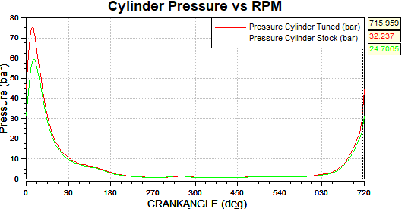

The Following is the change in the spark timing in tuned vs stock

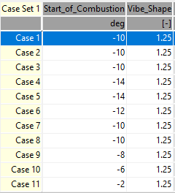 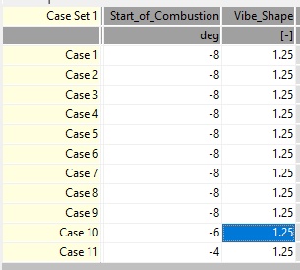

In Terms of CAM Phasing the intake and exhaust was shifted per RPM basis based on observing the intake and exhaust curves vs the crank angle and specific adjustments were made to the int_shift and exh_shift parameters to maximize torque and have maximum air movement as per the requirement and minimise the backpressure. A general trend can be observed and be worked upon for further optimizations is that with increasing rpm the int_shift is retarded and the exh_shift is retarded.

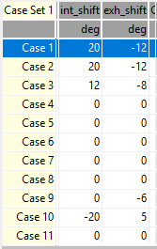

The volumetric efficiency is seen about 10% improved showing increase in the engine breathing, the BSFC is also improved and is lower by about 5g/kwh at most RPMs.

As Can be the seen the torque and the BMEP is improved by about 10% and 20% respectively for most of the range.

|  |  |  |  |  |  |
| --- | --- | --- | --- | --- | --- |
|  | | Benchmarking | | | |
| Specification | 2023 Honda CL 500 | | Yamaha SR 500 | Honda XBR 500 | Engine designed |
| Displacement | 471 cc | | 499 cc | 499 cc | 500 cc |
| Power | 34.3 kW | | 23.5 kW | 32.8 kW | 34 kW |
| Torque | 43.4 Nm | | 36.3 Nm | 42.7 Nm | 55 Nm |
| bore | 67 mm | | 87 mm | 92 mm | 86 mm |
| stroke | 66.8 mm | | 84 mm | 75 mm | 86 mm |
| Compression ratio | 10.7 | | 9 | 9 | 10.5 |
| Source | [2023 Honda CL 500](https://www.motorcyclespecs.co.za/model/Honda/honda-cl500-23.html) | | [Yamaha SR 500](https://www.motorcyclespecs.co.za/model/yamaha/yamaha_sr500%2080.htm) | [Honda XBR 500](https://www.motorcyclespecs.co.za/model/Honda/honda_xbr500_86.html) |  |

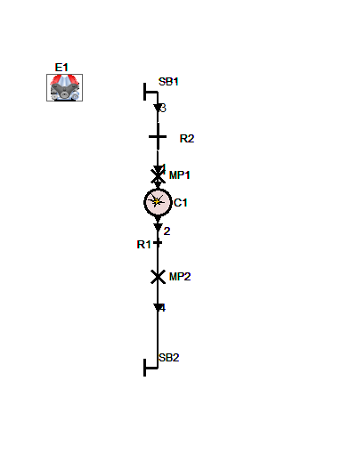The Image of the Model Task1

**Task 2**

Objectives –

* Optimise the intake geometry to improve overall engine performance metrics.
* Optimise camshaft phasing for enhanced performance across the same parameters.
* Overlay the optimised results on the same graphs as the baseline results for visual comparison.

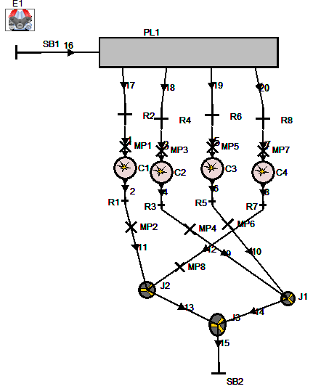

A 4-cylinder 2.0L engine was created by using engine model from Task 1 and further tuned for higher torque and BMEP. Two approaches were used for construction of this engine the 1st being by using junctions at intake and the 2nd being using an intake plenum, while this study was further tuned on the one using plenum since the one using junctions had uneven air delivery between cylinders that should be a scope of further study and graphs of that are shared further in this study. For the final tuning of the engine a plenum was used for efficient and equal air delivery to all 4 cylinders. For tuning of the engine multiple parameters listed below were changed and will be discussed further –

* The intake runner lengths
* The intake diameter
* Firing order of the cylinders
* Connection of Exhaust Ports
* Exhaust Runner length
* Exhaust Diameter
* Cam Phasing
* Spark Timing
* Plenum Volume
* Intake Trumpet Dimensions

**For Intake Trumpet Dimensions** maximised air intake is required into the plenum and with changing diameter for lower diameter of the trumpet the engine had a slightly higher lower torque at the extreme ends of the rpm range but a much lower max torque at mid range while vice versa for a higher diameter. After optimizing for both high and low end torque a trumpet diameter of 65mm was selected. Trumpet diameter is one of the major deciding factors in the torque characteristics of the engine.

The intake trumpet length didn’t have any significant effect on the torque character hence it was taken as 110 mm as a realistic value for packaging purpose.

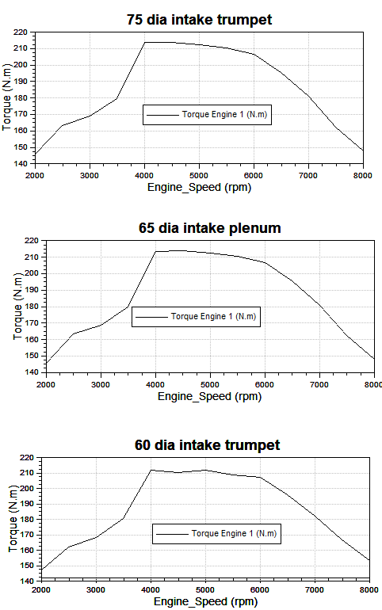

**For Plenum Dimensions -** A Plenum of 2L was selected so to match the air requirements of the engine. No further iteration was done but it will be interesting to see the effects of changing plenum volume and can be a further scope of study.

**For Intake Runner Dimensions** – As mentioned in Task1 wave dynamics tuning was done and length was selected as 240mm for a high torque in 4000-6000 RPM range. Also multiple iterations were done to optimize this value as it was found increasing or decreasing this value of intake RPM was found to be an issue with some or other RPM in terms on torque

Intake Runner diameter of 34 was selected based on multiple iterations as mentioned in task1 since varying the diameter varies torque on the higher end(increase with increasing diameter) and lower end(decreases with increasing diameter)

**For Exhaust runner dimensions** – The Exhaust runner diameter was chosen as 38mm and was supposed adequate the diameter after junction of two exhausts is 40 mm and the final exhaust runner has diameter is 42mm, the thinking behind this increasing diameter is use of these junctions as venturi meter to use lower pressure at the outgoing end to increase flow speed at junction and is quite interesting and must be studied further. The lengths are chosen adequate to the packaging for a front engine sports car.

**Firing Order** – The Firing order of the cylinders is selected as 1-3-4-2 which is quite common in 4-cylinder engines

**The exhaust connections** are 2-3 and 1-4 then all 4 are connected together the thinking behind this type of connection Is every bijunction of two exhausts has a exhaust wave in alternate cycle, so in order 1-3-4-2 the exhaust wave order for the bijunctions would be 1-4—2-3—1-4—2-3 which makes it balanced.

Cam Phasing – The cam phasing was done for tuning of the engine was done and the tuning is similar to task1 engine , with intake_shift retarding and exhaust_shift advancing as we move up the rpm, again this was manipulated by checking intake and exhaust curves at the specific RPMS to minimize back pressure.

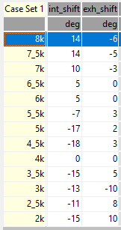

Spark Timing – The spark timing is seen advancing as we move up to higher RPMs as the spark must occur earlier to ensure peak pressure happens at the optimal crank angle for maximum power

The Performance Characteristics of Tuned Engine

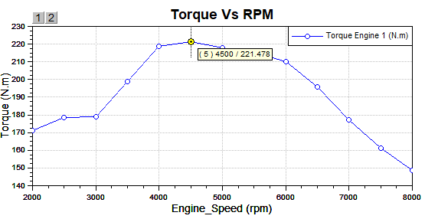

As seen in the torque map peak torque of 221 Nm is available at 4500 RPM which is a bit earlier but is great for low rpm applications and torque applications. This engine is good where there’s much higher requirements of higher accelerations and not so much of top speed.

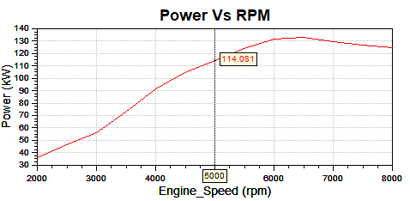

The Peak power is @6500RPM of about 135kW and reduces a bit as we move higher but the power gradient at 3000-6000RPM range is great with a great surge effect.

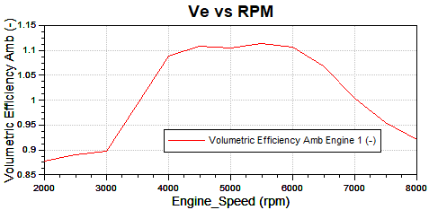

The volumetric efficiency shows similar trend to torque curve and is up to 112% which is greatly efficient for a naturally aspirated engine.

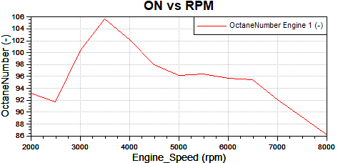

The ON is well below 100 for most of the curve as should be and the trend is decreasing complying with the general rule of ON decreasing with increasing RPM, the surge of ON between 3000-4000 RPM needs to be investigated further and most possibly the root cause is excess cam phasing at those RPMs.

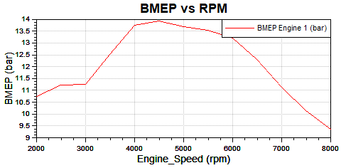

The BMEP is just similar to torque with same explanation for this as for torque

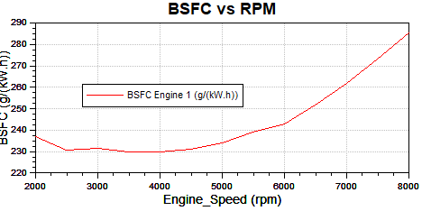

The BSFC here is very similar to the single cylinder engine and this just highlights this is actually just as efficient as the single cylinder engine

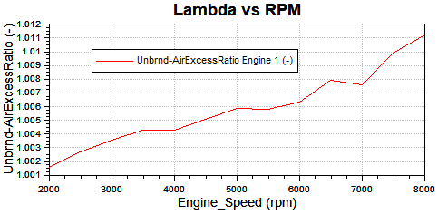

The Lambda vs RPM curve is very similar to the single cylinder engine as well as expected

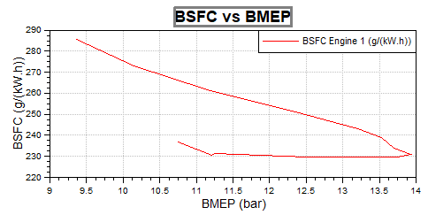

The BSFC vs BMEP is slightly worse than the single cylinder engine and cause for this needs to be studied further.

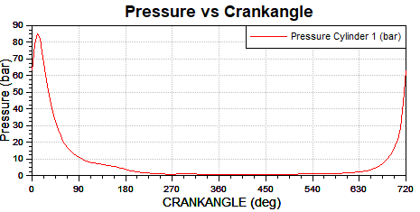

80Bar is the max cylinder pressure for the 4 cylinder engine

|  |  |  |  |
| --- | --- | --- | --- |
| **Benchmarking** | | | |
| Specification | Opel Vauxhaull C20NE | Opel Vauxhaull C20XE | Engine Tuned |
| Displacement | 2 L | 2 L | 2 L |
| Power | 85.75 kW | 111.85 kW | 135 kW |
| Torque | 170 Nm | 200 Nm | 221 Nm |
| bore | 86 mm | 86 mm | 86 mm |
| stroke | 86 mm | 86 mm | 86 mm |
| Compression ratio | 9.2 | 10.5 | 10.5 |
| Source | [Opel Vauxhaull C20NE](https://mymotorlist.com/engines/opel/c20ne/) | [Opel Vauxhall C20XE](https://mymotorlist.com/engines/opel/c20xe/) |  |

As mentioned Before the engine with junctions for intake –

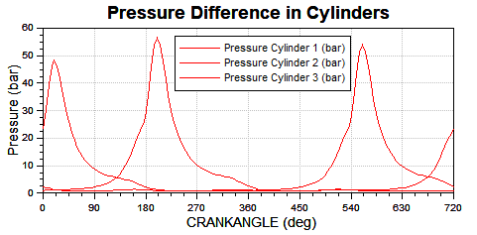

The pressures are different for different cylinders for same RPM which results in uneven combustion and uneven torque and hence a plenum model was preferred and used.

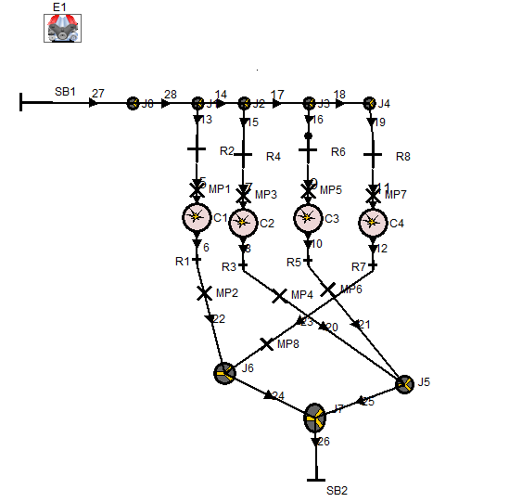

**Task 3**

Objectives –

* Optimise the intake, exhaust and camshaft systems in an effort to improve BMEP over engine speed range 2000-6500 revmin-1
* An intercooler and GDi should be included.

To Tune the 3 cylinder 1.0L engine the following parameters were changed

* Intake Runner Dimensions
* Exhaust Runner Dimensions
* Plenum Volume
* Intercooler Volume
* Spark Timing
* Turbo Efficiency
* Compressor Efficiency
* Cylinder Dimensions

**For Cylinder Dimensions** – Since the Cylinder in engine 1 is 500cc the new engine is supposed to be 333cc with some calculation, the Bore is set at 77.08mm and the stroke is set at 71.37mm being oversquare engine with expectation of peak torque at higher rpm. Although an amazing investigation can be done to optimize the bore stroke ratio with torque/bmep.

**For Intake Dimensio**ns – Multiple iterations were made w.r.t intake runner diameter and length and the same logic as task1 and task2, the diameter was selected as 36mm and the length was set at 80mm

**For exhaust dimensions** – Since the exhaust moves to turbo after multiple iterations the exhaust runner diameter was set as 36mm and the length at 140mm

**Plenum Volume** – Plenum volume was set at 1L to match the requirements of the engine.

**Intercooler Volume** – Intercooler almost had the most effect on the ON effect of the engine. Reducing the intercooler volume showed a decrease in the ON and vice versa. Also the intercooler length was increase a bit to 400mm and the volume was set at 1L.

**Turbo Efficiency** – to size the turbo accurately since the original turbo was much bigger for the 1L engine. The turbo discharge coefficient is set at 0.5 and turbo size multiplier is also set at 0.5. The Turbocharger overall efficiency is set as 0.6

**Compressor Efficiency** – To size the compressor efficiently the efficiency was set as 0.7 and as we know the turbine sets the sizing for the compressor.

**Spark Timing** – Spark Timing was observed to have the most effect on the ON of the combustion where advancing it was showing a very high ON and retarding it was reducing ON. After multiple iterations the following Spark timings were selected. As can be seen from the data the trend is increase in retarding as we move to higher rpm

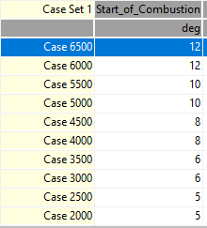

**Turbo-comp-ratio** – This was seen to have the most effect on the torque and combustion characteristics of the engine with a slight increase showing much higher change in torque.

The following is the turbo-comp-ratio used to tune the engine. As can be seen the ratio increases with RPM.

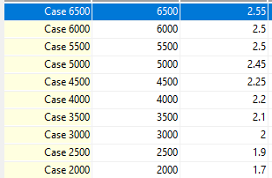

After tuning of the engine the following are the engine characteristic curves

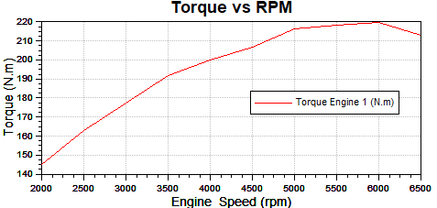

The peak torque of about 220Nm is observed at about 6000RPM and the torque is seen to be steadily increasing with a later peak torque.

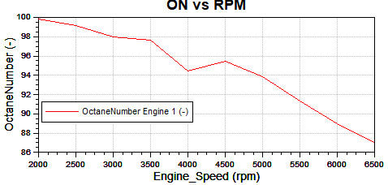

The ON vs RPM curve demonstrates that ON is decreasing with steady RPM as is expected and all of ON is below within limit showing no detonation

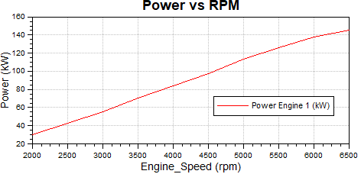

The Power Graph is as expected with steadily increasing with RPM with peak power of about 142KW.

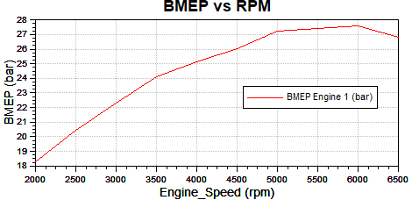

Similar to torque Curve but BMEP much higher than task2 4 cylinder engine since a compressor is being used here, so much higher pressure(approx. 2x) is available here.

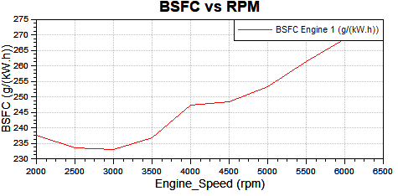

The BSFC vs RPM values are very similar to task 2 showing great deal of similarity in the fuel performance of the engine.

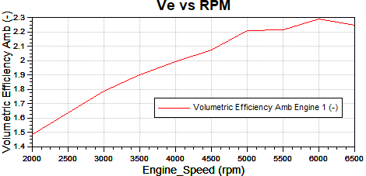

The Ve of this engine is much higher than (approx. 2x) of the task2 engine . This difference can be attributed to the use of compressor which puts more air into the cylinder which in turn increases the Ve of the Engine.

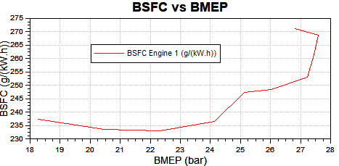

The BSFC vs BMEP here shows similarity with the overall results there’s similar BSFC as task 2 but at a higher BMEP(approx. 2x) to the task2 engine

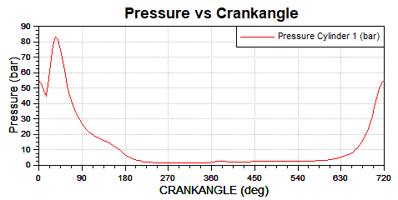

The peak Pressure (at highest torque) in the cylinder for this engine is nearly equal to the peak pressure(at highest torque) of a 4 cylinder engine.

The overall performance in terms of peak torque or power is very similar to task2 engine but it varies greatly wherever airmass and pressure is involved in calculations the values differ a lot and that difference can be attributed to use of a turbocharger.

|  |  |  |  |  |
| --- | --- | --- | --- | --- |
| Benchmarking | | | | |
| Specification | Ford 1L EcoBoost | Hyundai i20 N-line | VW Group 1L TSI | Engine designed |
| Displacement | 999 cc | 998 cc | 999 cc | 1 L |
| Power | 93.21 kW | 73.55 kW | 85 kW | 142 kW |
| Torque | 230 Nm | 172 Nm | 200 Nm | 220 Nm |
| bore | 71.9 mm | 71 mm | 74.5 mm | 77.08 mm |
| stroke | 82 mm | 84 mm | 76.4 mm | 71.37 mm |
| Compression ratio | 10 | 10.5 | 10.5 | 10.5 |
| Source | [Ford ecoboost](https://fordauthority.com/fmc/ford-motor-company-engines/ford-ecoboost-family/ford-1-0-liter-ecoboost-fox-engine/) | [Hyundai i20 N-line](https://www.hyundai.news/newsroom/dam/eu/models/20210610_sop_i20_n_and_i20_n_line/hyundai-sop-i20-and-i20-n-line-tech-data.pdf) | [VW Group 1L TSI](https://www.motorreviewer.com/engine.php?engine_id=130) |  |

**Task 4**

Objectives –

* To compare the 0-100 mph performance of the two-seater sportscar fitted with the Task 2 and Task 3 ICE
* The gear ratios should be re-optimised for the Task 2 and Task 3 engines

The following values are changed in the model which are common to both the engines in the vehicle model.

For the Tyre the coefficient is set at 1.05 which is considered within the range of 0.9 – 1.1 for a sports car

The Front rolling radius is set at 284mm and dynamic radius is set at 290mm

The Rear rolling radius is set at 297mm and dynamic radius is set at 303mm

The Curb weight is set at 720kgs as given in the sheet

The total weight is taken as 800kgs including the driver

The wheel load on all wheels is set at 1960N which is equal to 800*9.8/4 since the weight split is 50:50

The wheelbase is set at 2300mm

The COG height for empty load is set at 470mm, then lower it 460mm at half load and 450mm at full load which makes sense since added weight lowers the car.

The frontal area is set at 1.62m2

The lift coefficients are set according to the model. Which are negative and result in a downforce.

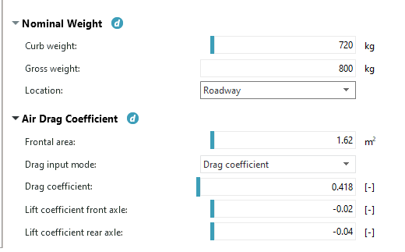

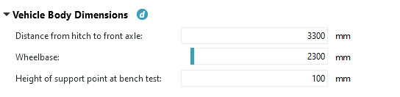

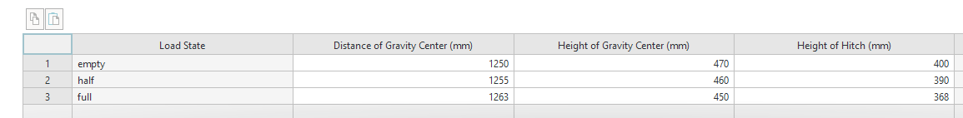

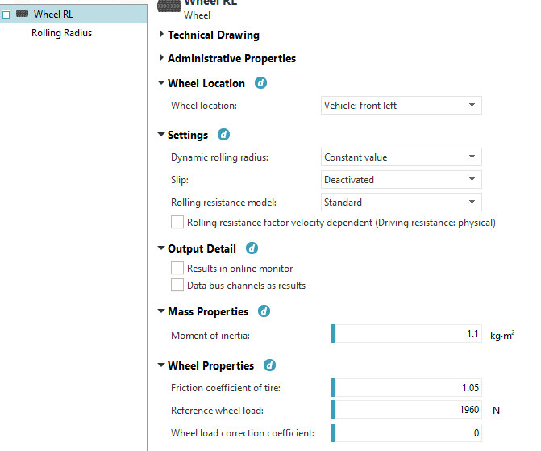

**For TASK 2 Engine**

Here the engine parameters are changed as per the task engine

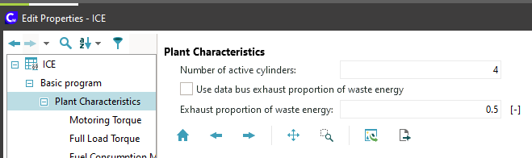

The engine map is changed as per torque engine

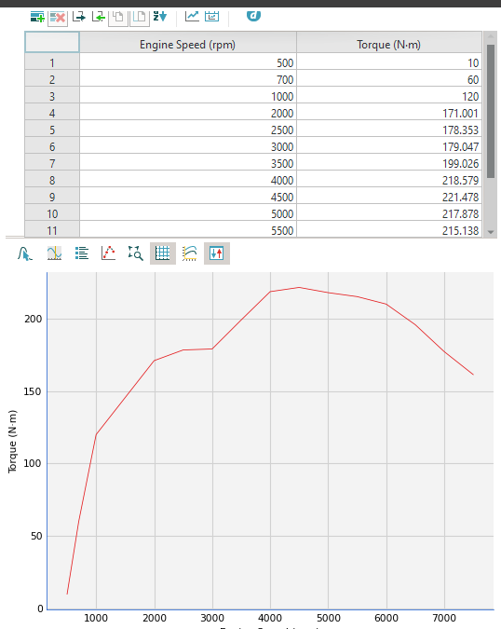

The fuel consumption was changed as per the task2 model

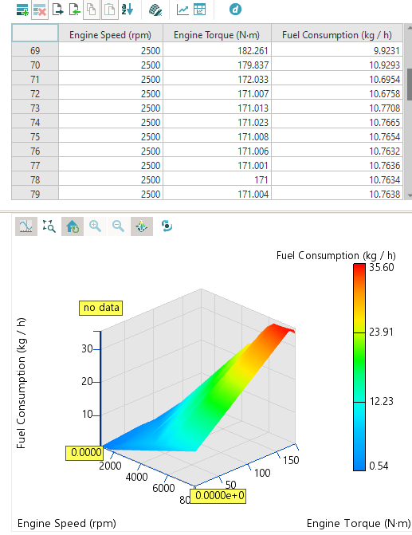

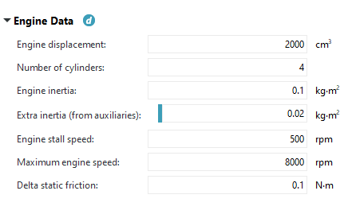

The engine data as changed in the ICE element

**For Unoptimized Gear Ratio**

Simulation Graph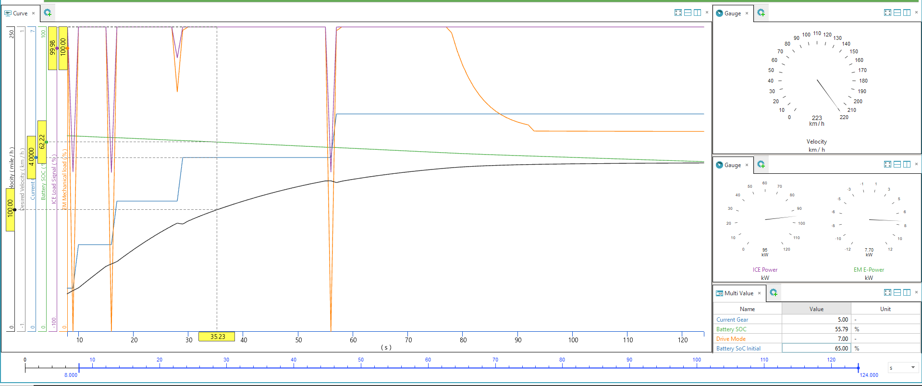

Top speed is 223km/h and the time to 100mph is 35.83S.

Potential load vs Actual Wheel Load

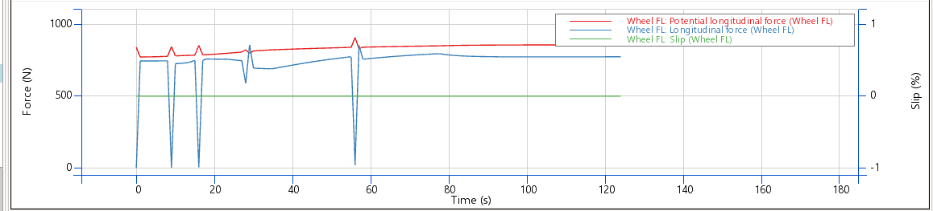

There’s still scope for optimization to get the wheel load as close to potential wheel load.

ICE Power vs EM Power

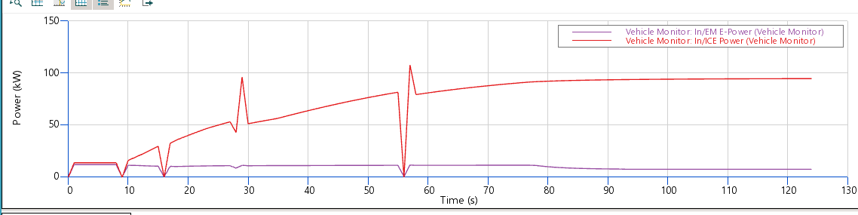

The ICE has a peak Power of 123KW and the EM has a peak power of 11.5KW.

EM Load vs Time

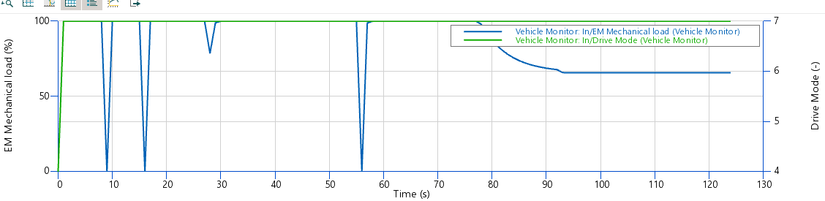

The EM load is at 100% for most of the cycle supporting engine at predefined loading bhaviour but dips after 80 secs and it seems to be some temperature or other configuration that is causing the dip and needs to be investigated further

**For Optimized Gear Ratios**

The understanding is having wheel longitudinal force lower than and as close to potential longitudinal force, since moving above the potential longitudinal force causes slip essentially and we want to avoid that.

Simulation Graph

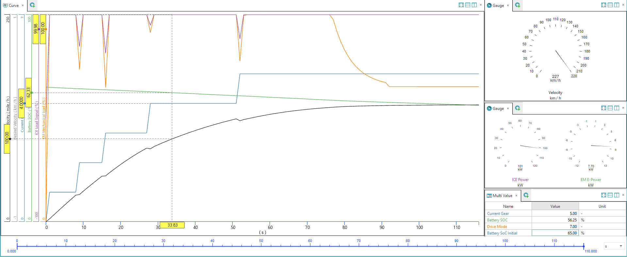

As seen in the image above the time taken for 100mph is 33.58Seconds reaching a top speed of 227km/h

Gear Ratios

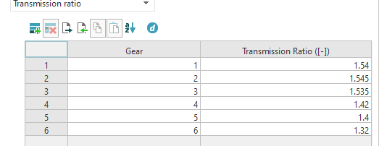

Potential wheel load vs Wheel load

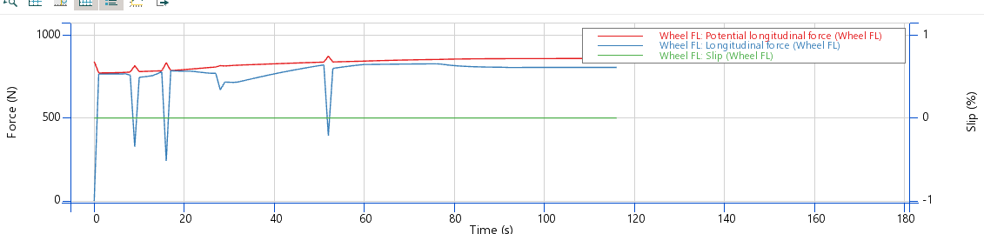

As can be seen from the graph the gears are optimized to keep the longitudinal force within the allowed range of Potential Longitudinal Force

ICE power vs EM power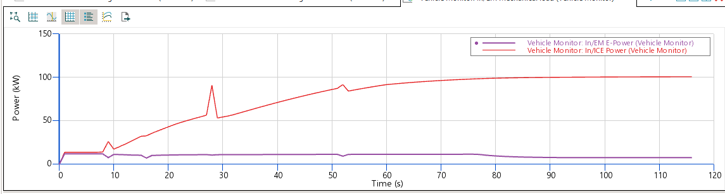

As can be seen the ICE power does keep on steady increase but the EM power reaches a steady state as is the expected behaviour from an EM. The power/torque characteristics of the EM are supposed to be investigated further so as to optimize the performance of the engine

Battery SOC vs Time

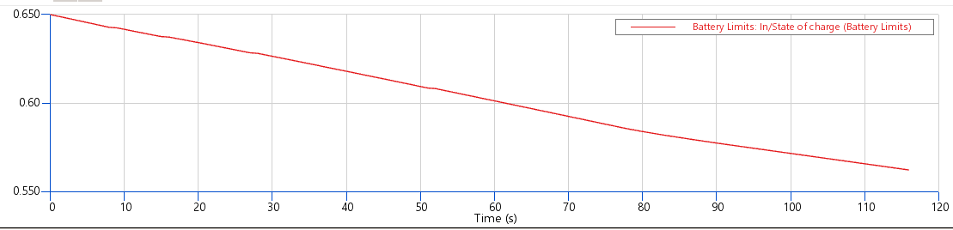As Expected the EM is being engaged and drawing power from the battery and the SOC declines by about 9.5%

**For Task 3 Engine**

Here the engine parameters are changed as per the task engine

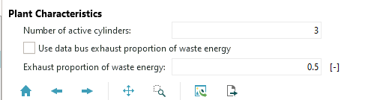

The engine map is changed as per torque engine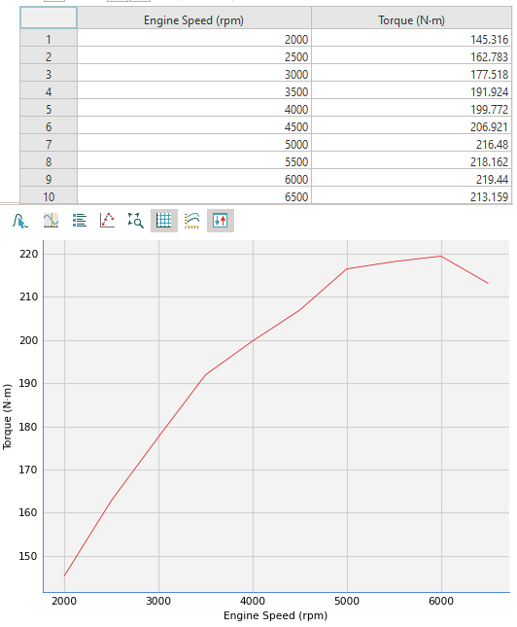

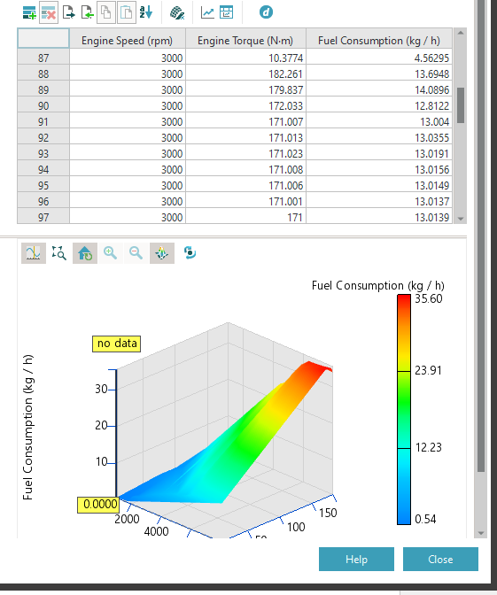

The fuel consumption was changed as per the task3 model

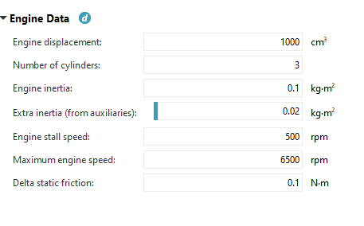

The engine data as changed in the ICE element

**For Unoptimized Gear Ratio**

Simulation Graph 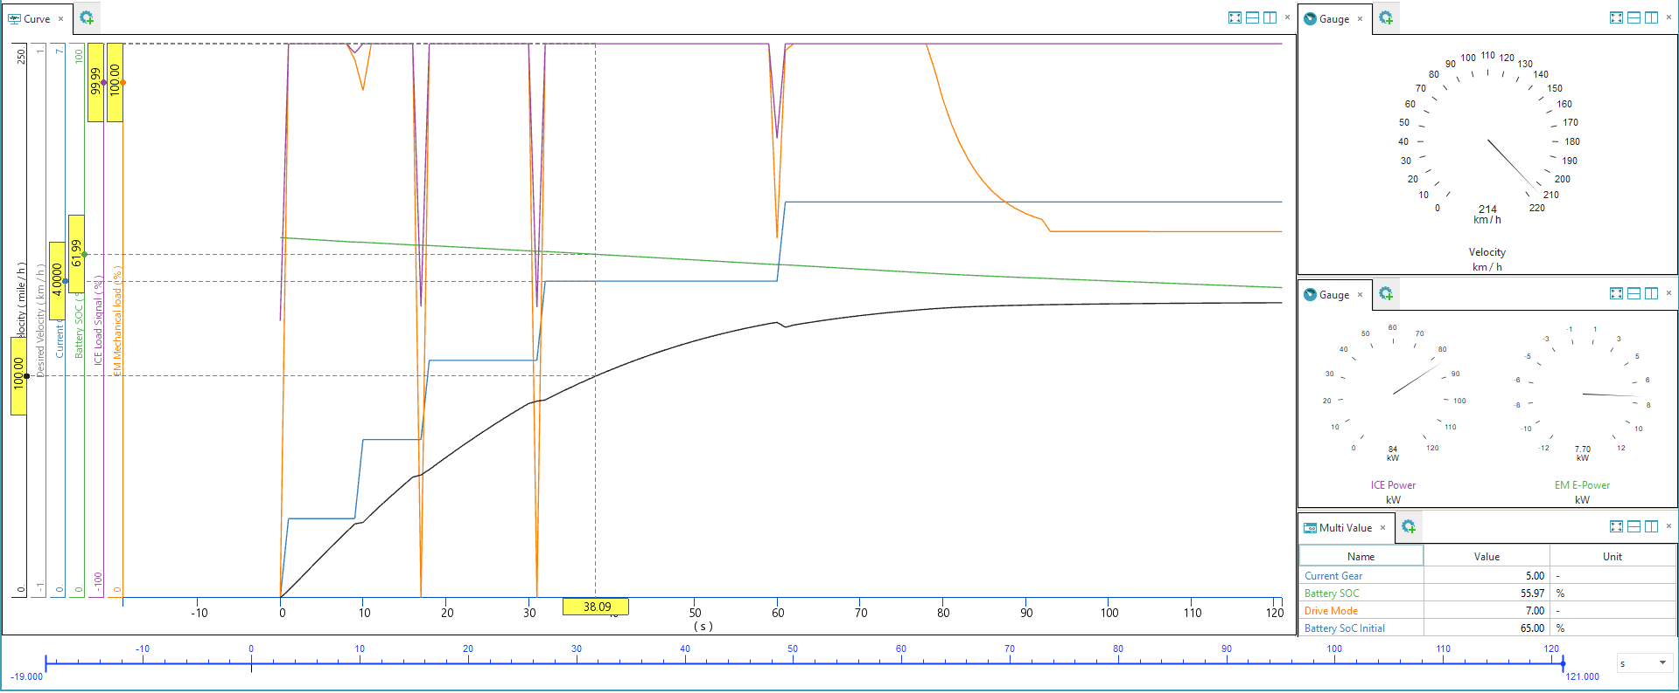

Top speed is 214km/h and the time to 100mph is 38.39S.

Potential load vs Actual Wheel Load

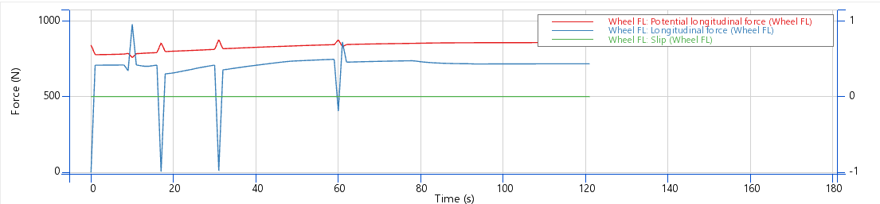

There’s still scope for optimization to get the wheel load as close to potential wheel load.

ICE Power vs EM Power

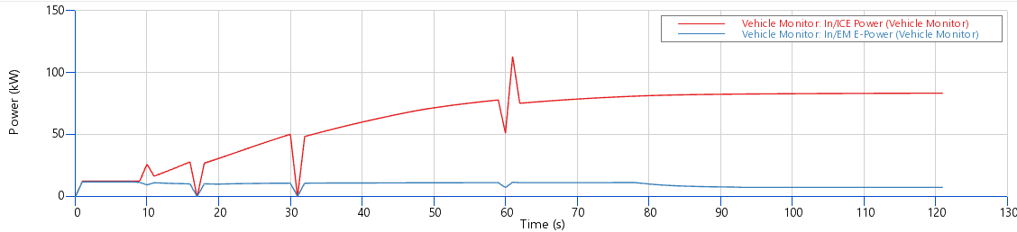

The ICE has a peak Power of 113KW and the EM has a peak power of 12.18KW.

EM Load vs Time



The EM load is at 100% for most of the cycle supporting engine at predefined loading behaviour but dips after 80 secs and it seems to be some temperature or other configuration that is causing the dip and needs to be investigated further

**For Optimized Gear Ratios**

The understanding is having wheel longitudinal force lower than and as close to potential longitudinal force, since moving above the potential longitudinal force causes slip essentially and we want to avoid that.

Simulation Graph

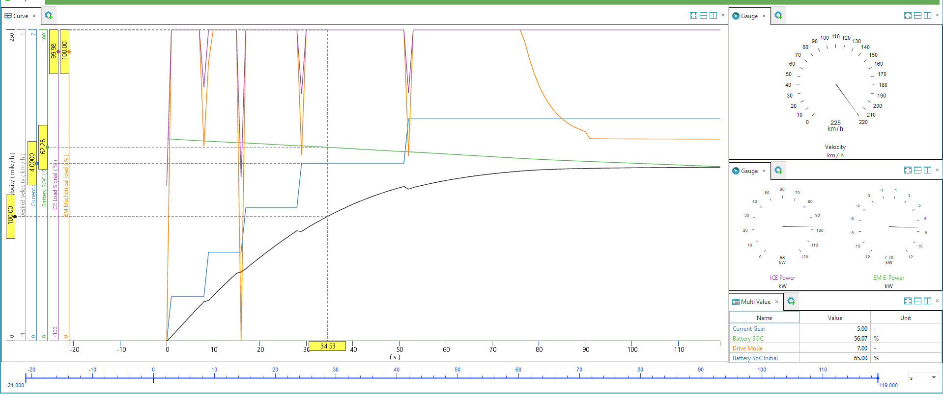

As seen in the image above the time taken for 100mph is 34.53Seconds reaching a top speed of 225km/h

Gear Ratios

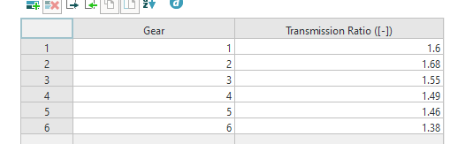

Potential wheel load vs Wheel load

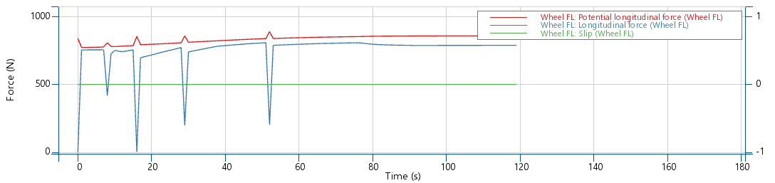

As can be seen from the graph the gears are optimized to keep the longitudinal force within the allowed range of Potential Longitudinal Force

ICE power vs EM power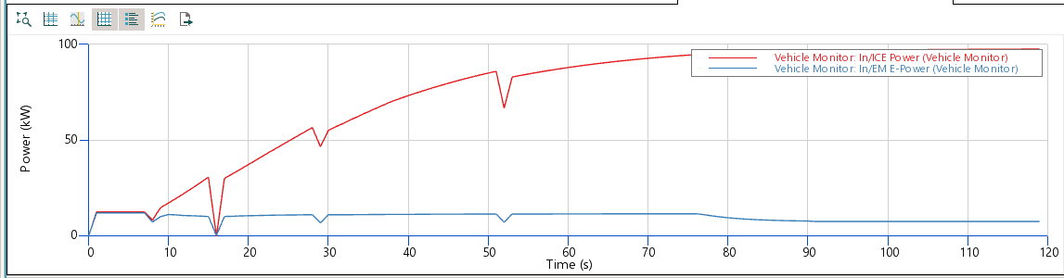

As can be seen the ICE power does keep on steady increase but the EM power reaches a steady state as is the expected behaviour from an EM. The power/torque characteristics of the EM are supposed to be investigated further so as to optimize the performance of the engine

Battery SOC vs Time 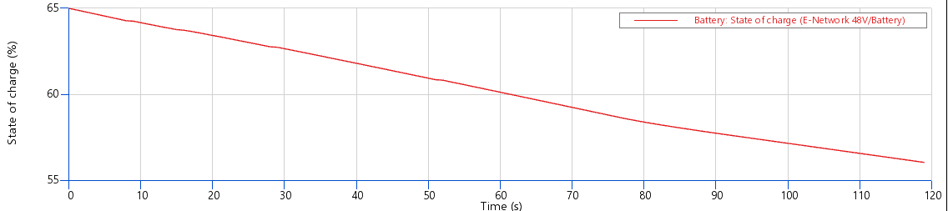As Expected the EM is being engaged and drawing power from the battery and the SOC declines by about 9.5%

**Comparison**

As seen in both the graphs

|  |  |  |  |  |  |
| --- | --- | --- | --- | --- | --- |
| Parameter | Top Speed(kmph) | Time to 100mph(s) | Peak  Power(kw) | Peak Torque(Nm) | Peak Torque @ RPM |
| Task2 – E | 228 | 33.58 | 132 | 221.478 | 4500 |
| Task3 - E | 225 | 34.53 | 142 | 219.44 | 6000 |

As can be seen Task2- E performs better in this comparison because mainly the torque peaks at lower RPM for task 2 and with the way gear shifting is configured task 2 engine proves better in performance to Task3 -E.

**The Performance of this model can be improved by changing EM – 1 Map or by changing the gear switching logic or/and changing the hybrid system logic.**

**References**

1. Motorcycle Specs. (n.d.). *Honda CL500 (2023)*. Retrieved October 17, 2025, from <http://motorcyclespecs.co.za/model/Honda/honda-cl500-23.html>
2. Motorcycle Specs. (n.d.). *Yamaha SR500 (1980)*. Retrieved October 17, 2025, from <https://www.motorcyclespecs.co.za/model/yamaha/yamaha_sr500%2080.htm>
3. Motorcycle Specs. (n.d.). *Honda XBR500 (1986)*. Retrieved October 17, 2025, from <https://www.motorcyclespecs.co.za/model/Honda/honda_xbr500_86.html>
4. MyMotorlist. (n.d.). *Opel C20NE engine*. Retrieved October 17, 2025, from <https://mymotorlist.com/engines/opel/c20ne/>
5. MyMotorlist. (n.d.). *Opel C20XE engine*. Retrieved October 17, 2025, from <https://mymotorlist.com/engines/opel/c20xe/>
6. Honda Newsroom. (2006). *2006 Honda S2000 specifications*. Retrieved October 17, 2025, from <https://hondanews.com/en-US/releases/release-5a35f67b82f245d1db31c6004c34c121-2006-honda-s2000-spec…>
7. Ford Authority. (n.d.). *Ford 1.0-liter EcoBoost “Fox” engine*. Retrieved October 17, 2025, from [https://fordauthority.com/fmc/ford-motor-company-engines/ford-ecoboost-family/ford-1-0-liter-ecoboo…](https://fordauthority.com/fmc/ford-motor-company-engines/ford-ecoboost-family/ford-1-0-liter-ecoboost-fox-engine/)
8. Hyundai Newsroom. (2021). *Hyundai i20 N and i20 N Line technical data* [PDF]. Retrieved October 17, 2025, from <https://www.hyundai.news/newsroom/dam/eu/models/20210610_sop_i20_n_and_i20_n_line/hyundai-sop-i20-a…>
9. MotorReviewer. (n.d.). *BMW B58 engine (3.0L inline-six turbo)*. Retrieved October 17, 2025, from <https://www.motorreviewer.com/engine.php?engine_id=130>